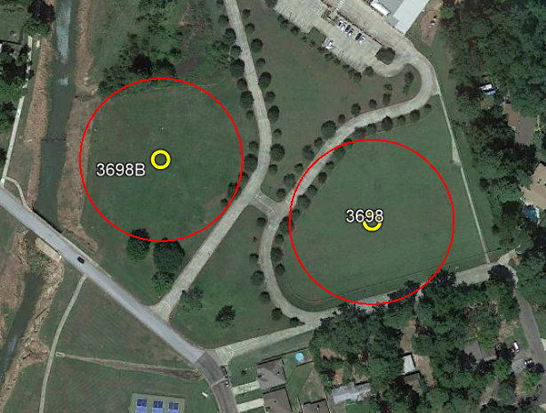
Task 2 CRAT
B
A
Marker Orange – Free

Valid times for scoring area
minutes – seconds after the hour
B A
00.00 – 09.59 10.00 - 19.59
20.00 – 29.59 30.00 - 39.59
40.00 - 49.59 50.00 - 59.59
June 14, 2023

